**SUPPLEMENTAL MATERIAL**

**Methods**

Western blotting was performed in either reducing or non- reducing conditions in 5% blotto (5% milk in TBS-T pH 7.4). Blots were blocked for 30 minutes in 5% blotto and incubated in primary antibody overnight at 4*C. After overnight incubation blots were then washed 3 x 5 minutes in TBS-T pH 7.4 and incubated for 1 hour in secondary antibody at room temperature. After incubation blots were then washed 3 x 5 minutes in TBS-T pH 7.4 and imaged on the ImageQuant™ LAS 500 (GE Healthcare).

Table 1. Primary antibodies used for western blotting.

|  |  |  |  |
| --- | --- | --- | --- |
| Antibody | Manufacturer | Cat. # | Dilution |
| β-Actin (Mse IgG1) | Santa Cruz | sc-517582 | 1:200 |
| Calnexin (Mse IgG) | Thermo Fisher Scientific | MA3-027 | 1:1000 |
| CD9 (Rbt IgG) | Thermo Fisher Scientific | PA5-11559 | 1:1000 |
| CD63 (Mse IgG)* | Thermo Fisher Scientific | 10628D | 2ug/mL |
| CD81 (Mse IgG1) | Thermo Fisher Scientific | MA5-13548 | 1:500 |
| GM130 (Mse IgG2a) | Santa Cruz | Sc-55591 | 1:500 |
| Syntenin (Goat IgG) | Thermo Fisher Scientific | PA5-18595 | 0.01 ug/mL |
| *non-reducing conditions. | | | |

Table 2. Secondary antibodies used for western blotting.

|  |  |  |  |
| --- | --- | --- | --- |
| Antibody | Manufacturer | Cat. # | Dilution |
| Goat anti-Rabbit IgG (H+L) Secondary Antibody, HRP | Thermo Fisher Scientific | 31460 | 1:10,000 |
| Goat anti-Mouse IgG (H+L) Secondary Antibody, HRP | Thermo Fisher Scientific | 31430 | 1:10,000 |
| Rabbit anti-Goat IgG (H+L) Secondary Antibody, HRP | Thermo Fisher Scientific | 31402 | 1:10,000 |

**Figures**

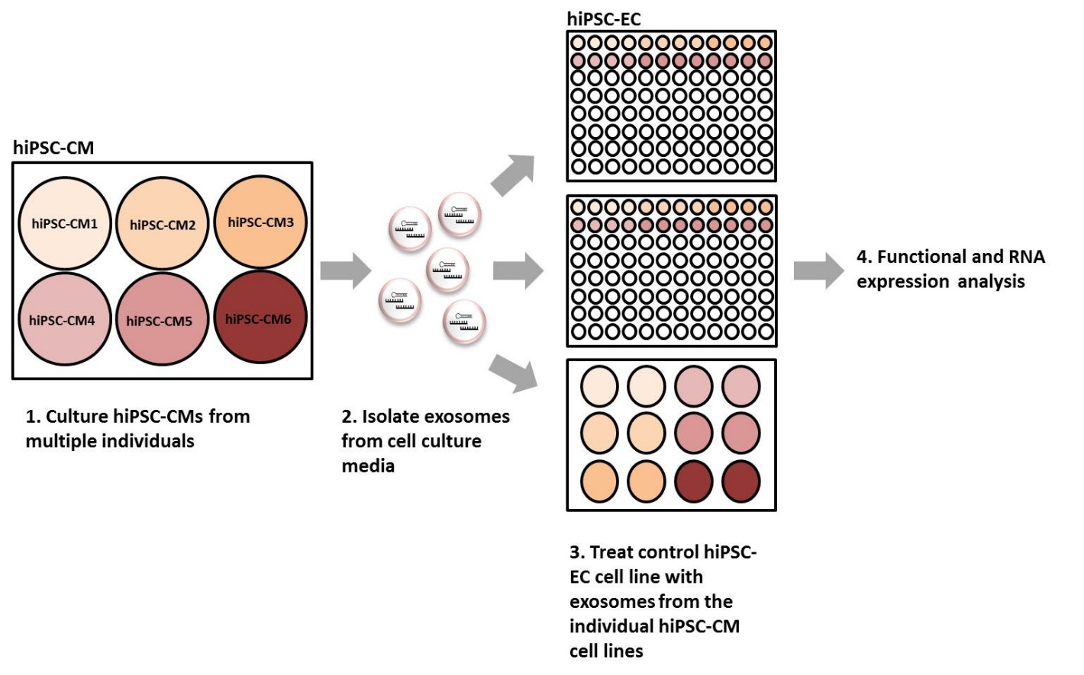

**Supplemental Figure 1. Experimental model**. Human iPSC-CMs from six individuals (three LVH affected and three unaffected) were cultured and exosomes were isolated from the cell-conditioned media. These exosomes were then applied to hiPSC-ECs and different functional and expression analyses were performed. These analyses included measurements of tube formation, migration, cell proliferation and differential RNA expression.

**Supplemental Table 1.** Differentially expressed mRNA (FDR ≤0.05) between the hiPSC-CMLVH (n=3) and hiPSC-CMCtrl (n=3).

**Supplemental Table 2.** Differentially expressed cellular miRNA (p-value ≤0.05) between the hiPSC-CMLVH (n=3) and hiPSC-CMCtrl (n=3).

**Supplemental Table 3.** Differentially expressed exosomal miRNA (p-value ≤0.05) between the hiPSC-CMLVH (n=3) and hiPSC-CMCtrl (n=3).

**Supplemental Table 4.** IPA identified differentially expressed cellular miRNA hiPSC-CMLVH (n=3) and hiPSC-CMCtrl (n=3) and their predicted direct mRNA targets which show inverse expression patterns.

**Supplemental Table 5.** Differentially expressed mRNA (FDR ≤0.05) between the EC-ExoCtrl (n=6) and EC-ExoLVH (n=6).

**Supplemental Table 6.** IPA identified differentially expressed exosomal miRNA EC-ExoCtrl (n=6) and EC-ExoLVH (n=6) and their predicted direct mRNA targets which show inverse expression patterns.

**Supplemental Table 7.** IPA Disease and bio function analysis of the differentially expressed mRNAs between the EC-ExoLVH (n=6) and EC-ExoCtrl (n=6).